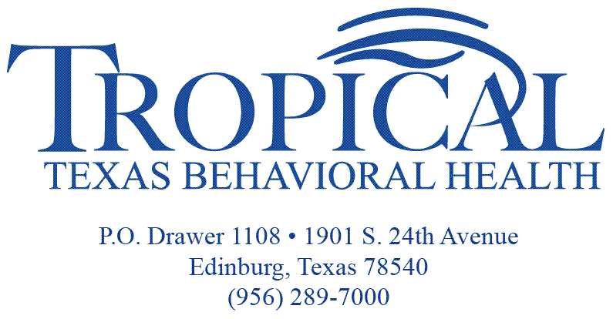

What Is IDD?

An Intellectual or developmental disability, also called IDD, includes many severe, chronic conditions that are due to mental and/or physical impairments. An Intellectual Disability should be diagnosed before the age of 18 years of age. It usually lasts throughout a person’s lifetime. People who have IDD have problems with major life activities such as:
- Language
- Mobility
- Learning
- Self-help
- Independent living

To get services, the following must apply:
- You must have a diagnosis of IDD, and/or
- You must have a pervasive developmental disorder, such as autism, as defined in the current edition of the Diagnostic and Statistical Manual (additional criteria needed depending on program), and/or
- You must have a related condition and be eligible for, and enroll in, an HHSC program that serves people with IDD.
- You must be a nursing home resident with a diagnosis of IDD or a related condition.
- You must be eligible for Early Childhood Intervention Services.

Where Can I Receive Services If I Have IDD?

People with IDD can choose where to live. Where you live depends on what you want, as well as which services you qualify for. You can live in:
- Your own home
- A group home with other people with IDD
- An intermediate care facility for individuals with an intellectual disability or a related condition (ICF/IID) in your community
- A state supported living center

Where Do I Call to Get These Services?

Begin by calling the TTBH IDD Department, which will guide you through the application and eligibility process.

Hidalgo County IDD Clerk 956-289-7233
Hidalgo County IDD Clerk 956-381-3012
Cameron County IDD Eligibility Worker 956-364-6646

Interest List

Even if you are eligible, you may not be able to get some services right away. In some cases, more people want services than the state has money to pay for. Your name would be placed on an interest list until there is an opening in the program you want services from.

Home and Community-based Services Program
People who get services from the Home and Community-based Services (HCS) program can live in their own home or in a small group home. You get to help decide on the types of services you get. This is called your individual service plan. This plan is reviewed once a year to see if it still works for you. People in HCS may get:
Adaptive Aids Caregiver Respite
Daytime Programs Dental Treatment
Nursing Services Specialized Therapies
Supported Employment PAS/HAB
Host Home/Companion Care Behavior Supports

Group Homes
If you live in an HCS group home, you will share a home with up to 4 people who also have IDD. People will help you take medicine, get dressed or bathe, cook, and manage your behaviors.

Texas Home Living Program
Texas Home Living (TxHmL) helps people with IDD who live with their families or in their own homes. You get to help decide on the types of services you get. This is called your individual service plan. This plan is reviewed once a year. The plan can be changed as needed. If you qualify for the TxHmL program, you might receive:
Adaptive Aids Behavior Support
Caregiver Respite PAS/HAB
Day Time Programs Dental Treatment
Nursing Services Supported Employment
Employment Assistance Specialized Therapies

Other Programs/Services
Eligibility Determination
Service Coordination
General Revenue
Community First Choice
State Supported Living Center
Intermediate Care Facility for Individuals with ID

